RECOVERING FILES FROM FORENSIC IMAGES WITH FTK IMAGER LAB.

STEP 4- From the main menu I select file then select add evidence .
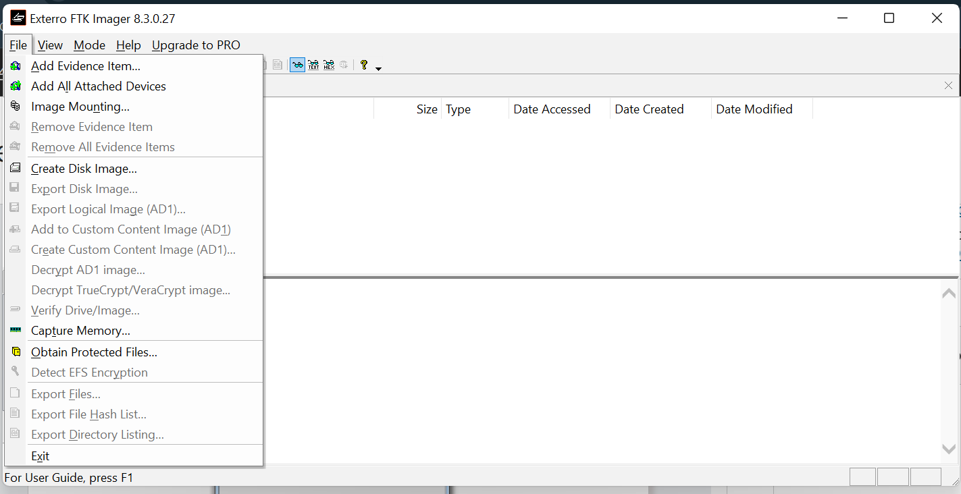

STEP 5-I am prompted to choose a source type, and I selected “ Image file” then we click next .
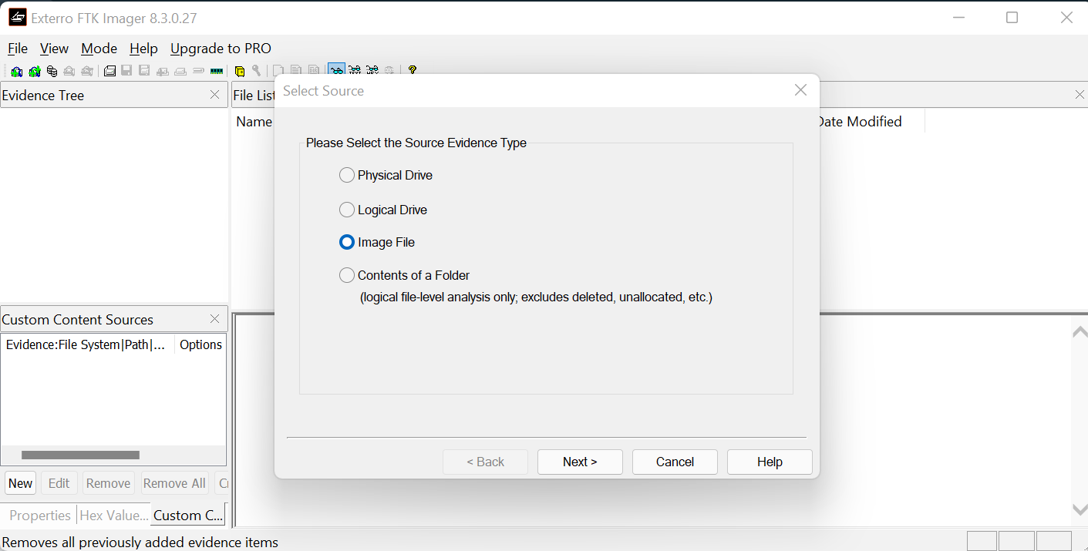

STEP 6- I browse to the desktop and select drive2.E01 and click finish.
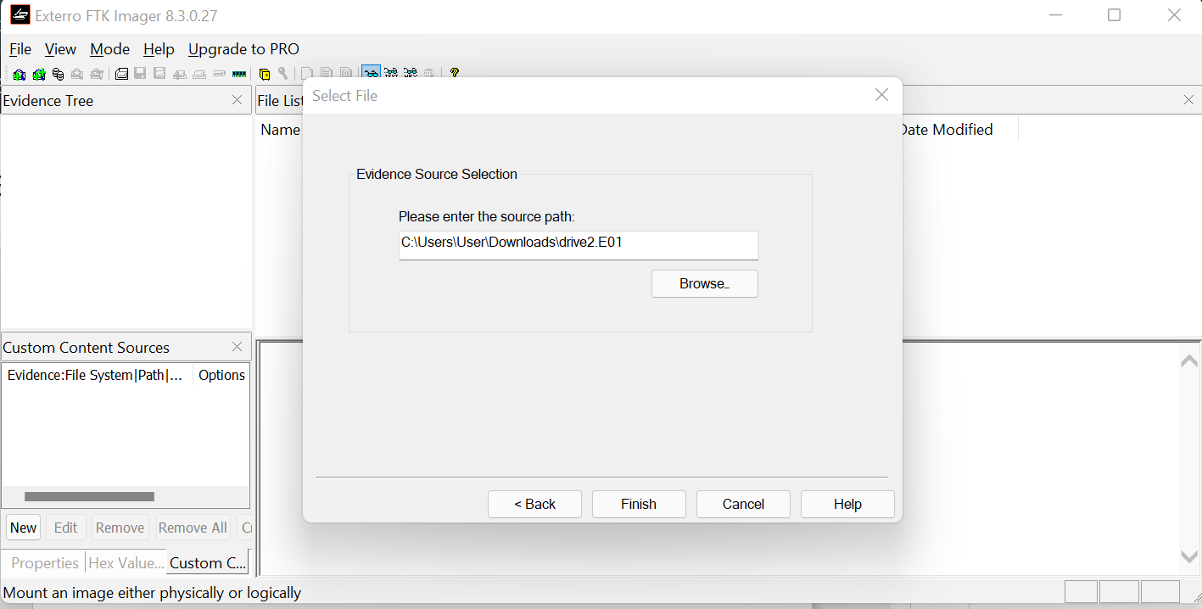

STEP 7:The FTK imager mounts the evidence file as shown.
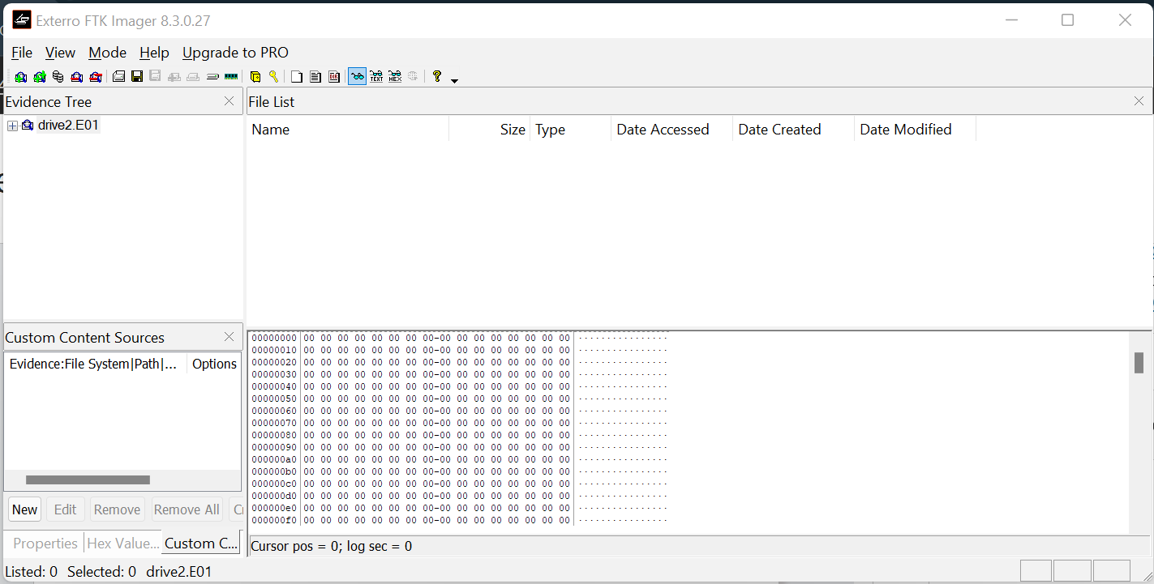

STEP 9- I click on the plus button next to the drive to expand the directory structure and from here I can see the expanded tree structure, volumes name and file system.
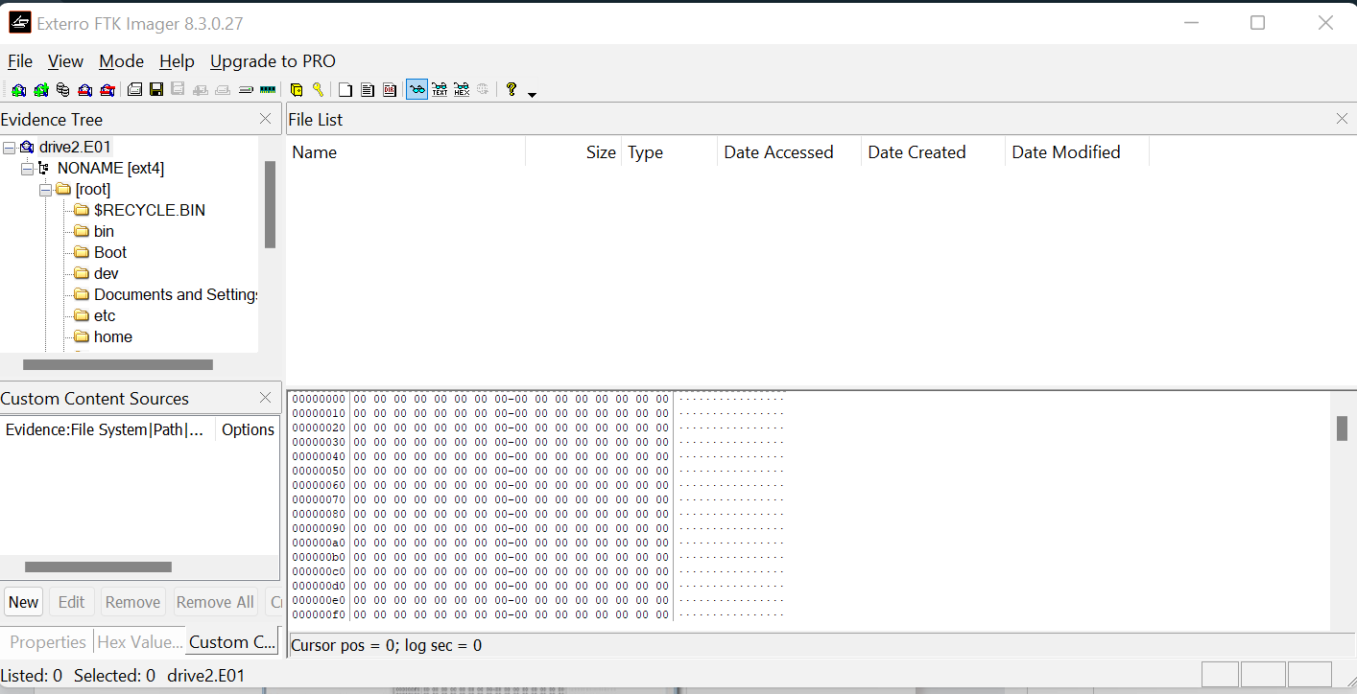

STEP 10:I navigate the file structure to go to \root\Windows\systems32
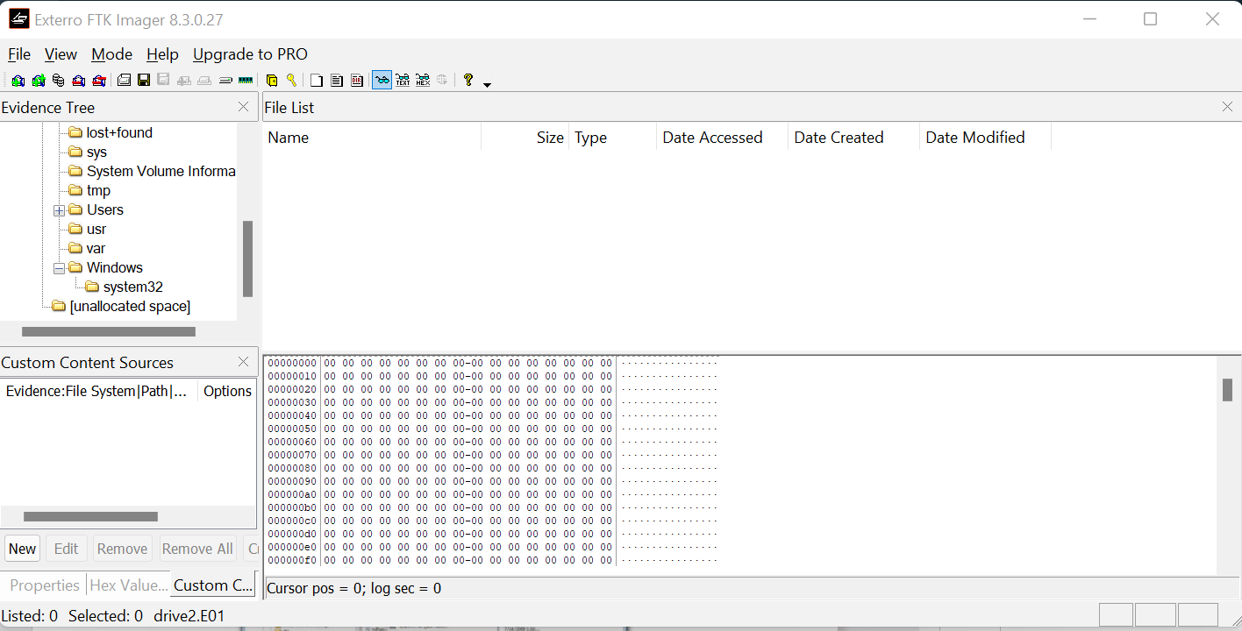

STEP 11-To extract file named ndadmin, I right click on the file and select “ Export files”, choose a destination for the file then click “OK”.
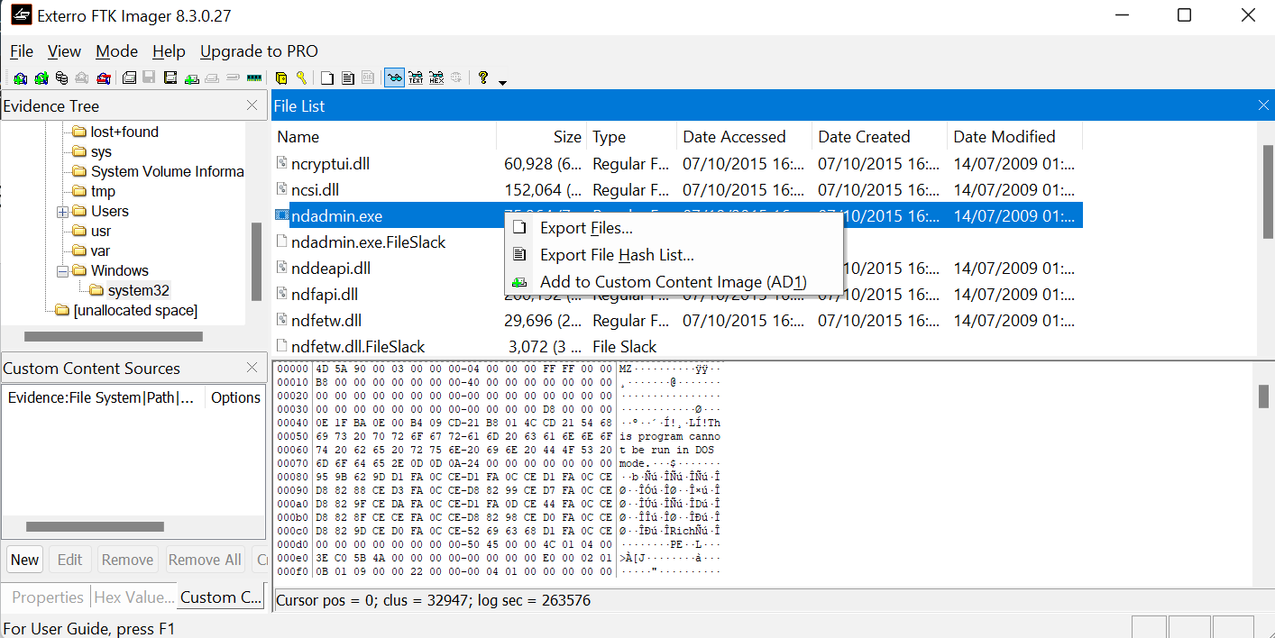

STEP 13-The result of the extraction along with the files size will is shown
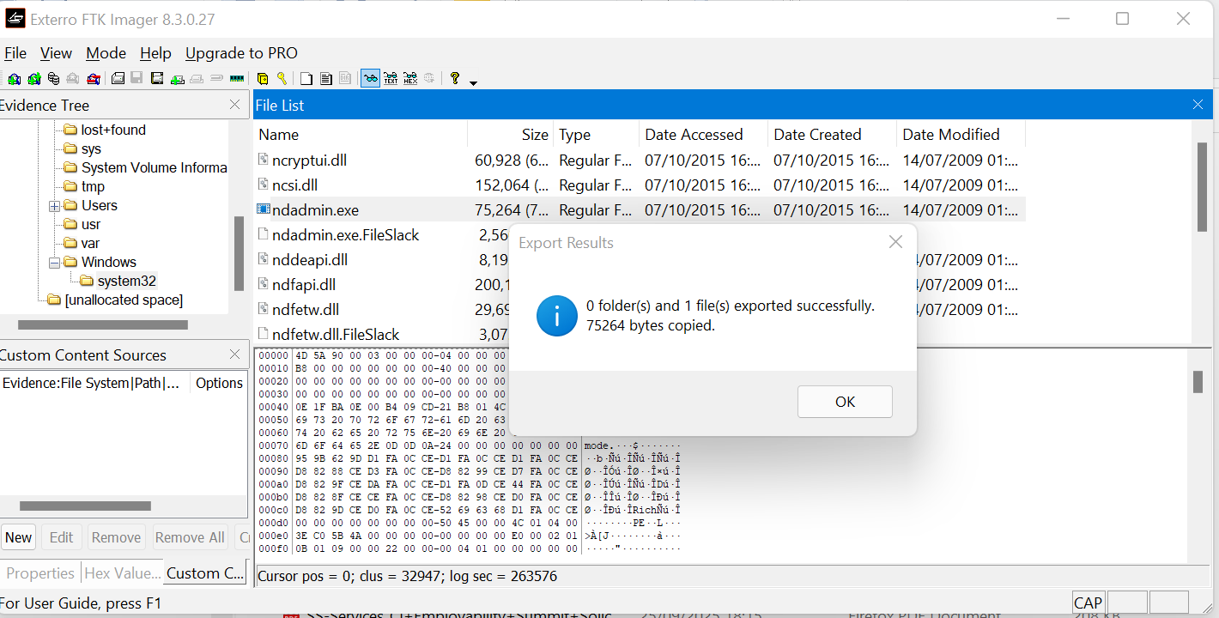

STEP 14-I tried to recover multiple files by holding the shift button and clicking on the files I want to extract then right clicking and selecting “ Export files”.
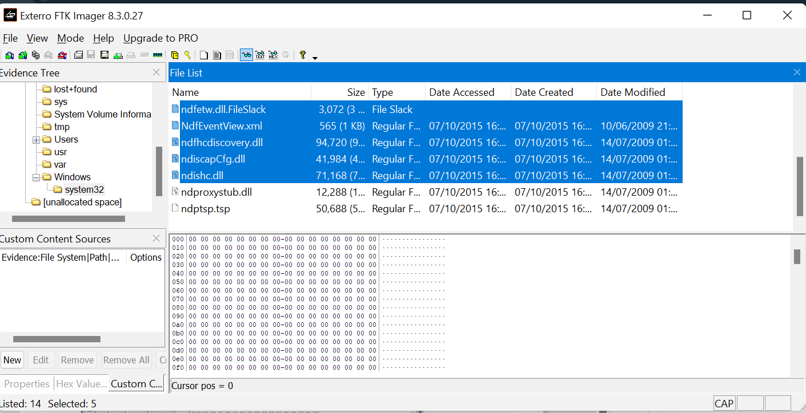

STEP 15
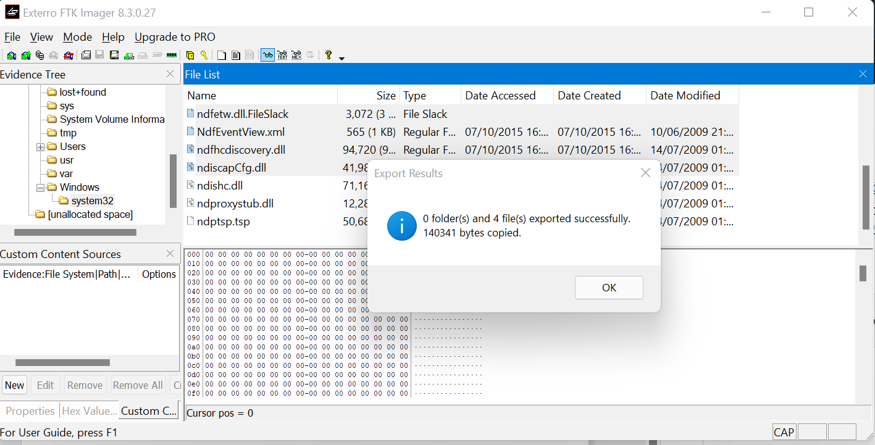

ADDITIONAL EXERCISE

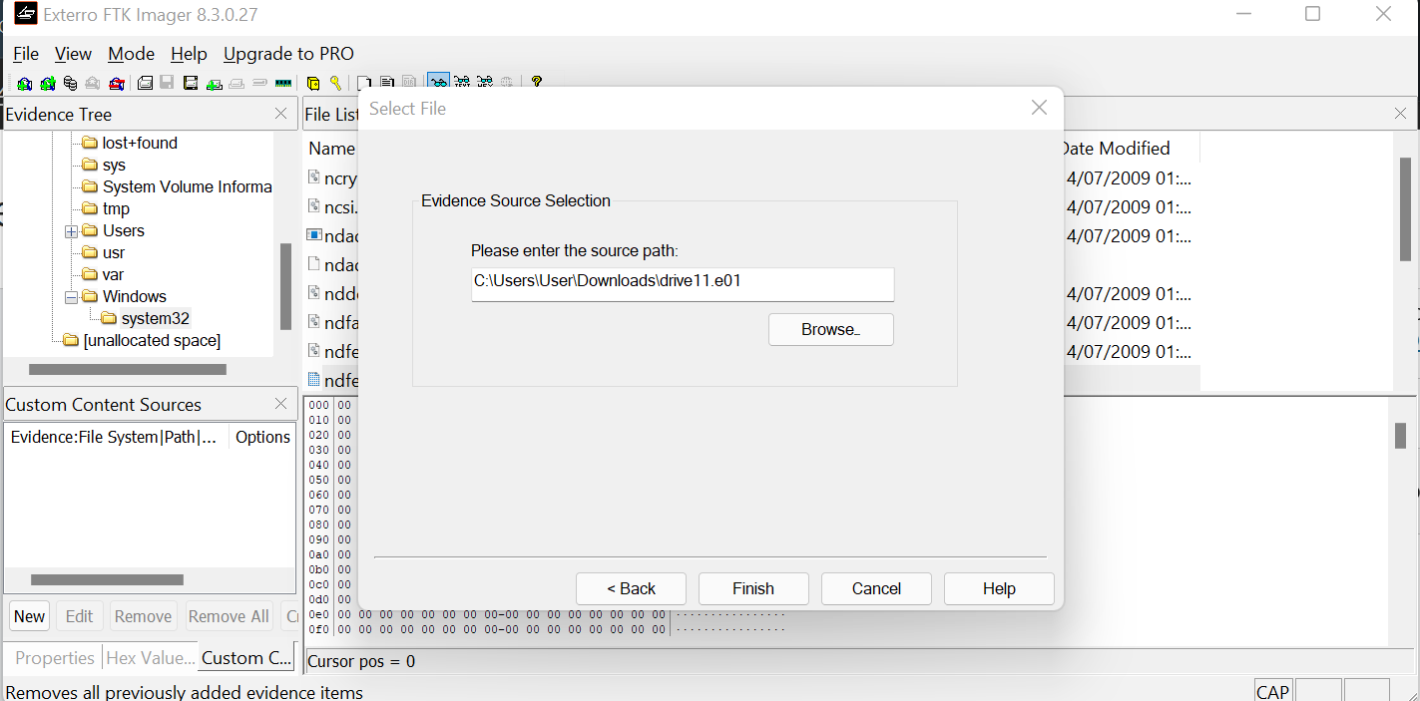

- Recovering files.
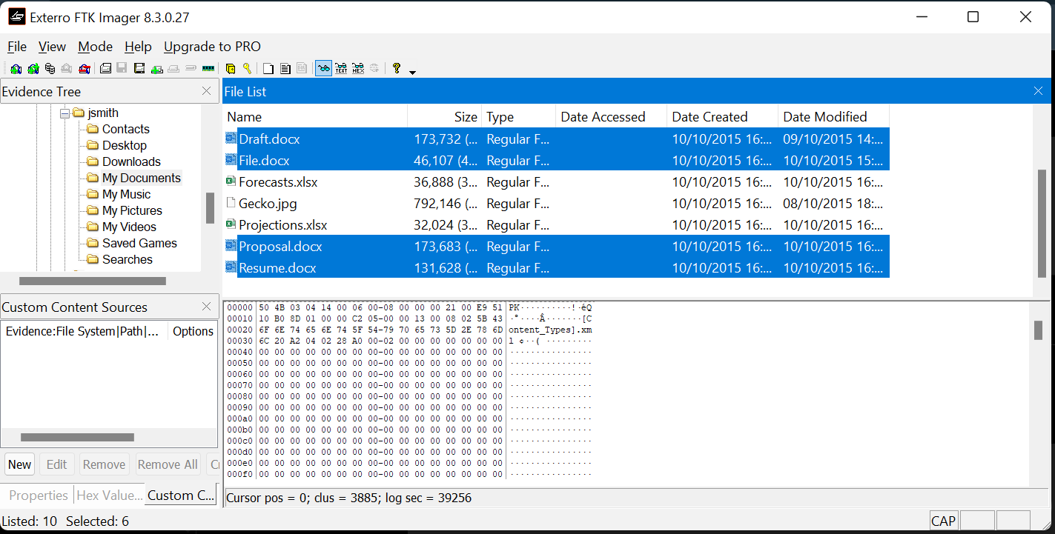

- There are 6-word documents.
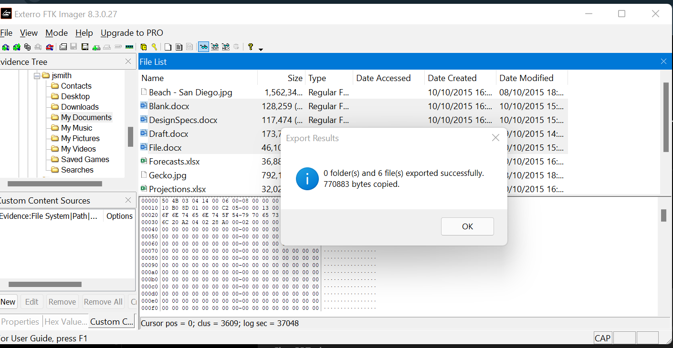

- NAME AND SIZE OF WORD DOCUMENTS

WORD DOCUMENT | SIZE
Blank.docx | 128,259
DesignSpecs.docx | 117,474
Draft.docx | 173,732
File.docx | 46,107
Proposal.docx | 173,683
Resume.docx | 131,628

- 2 files are executable.
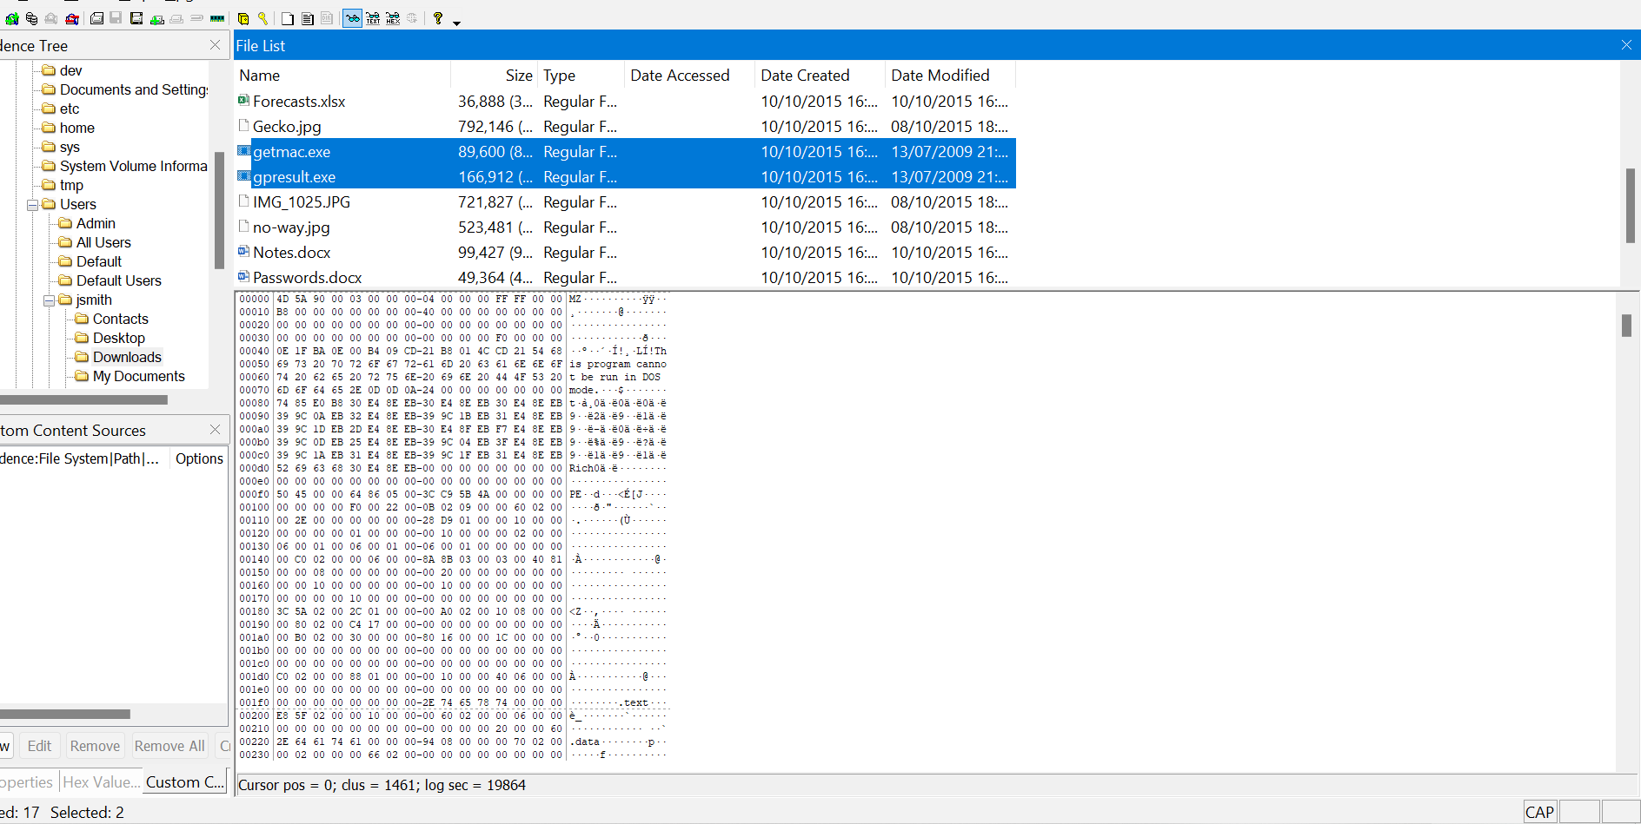
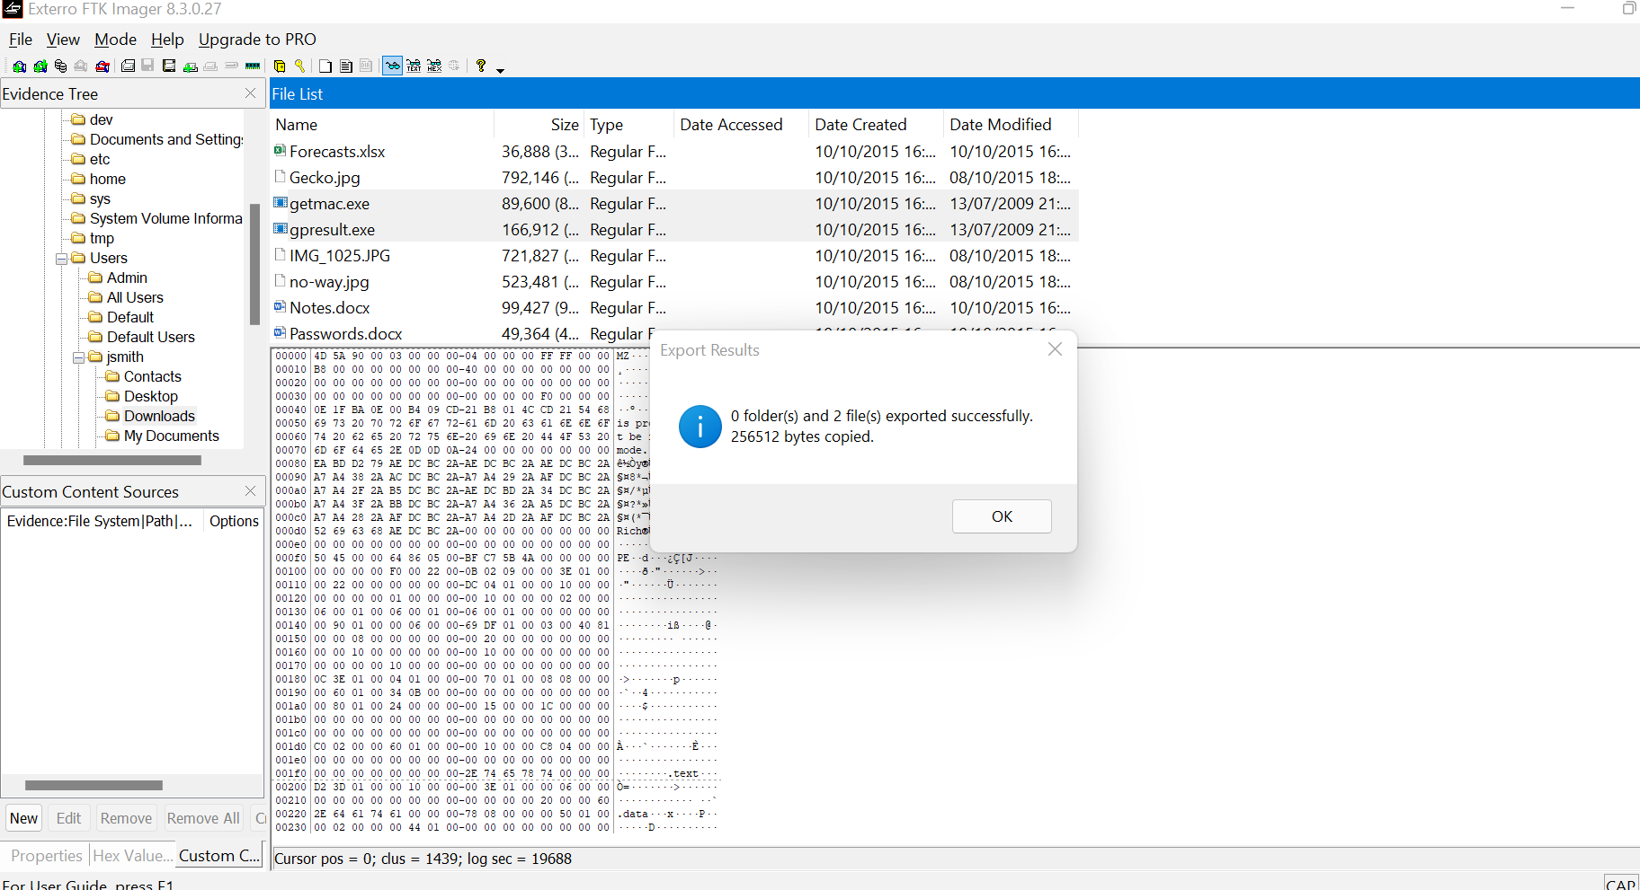

- NAME AND SIZE OF THE EXECUTABLES.
FILE | SIZE
getma.exe | 89,600
Gpresult.exe | 166,912

- 2 excel spreadsheets were recovered.
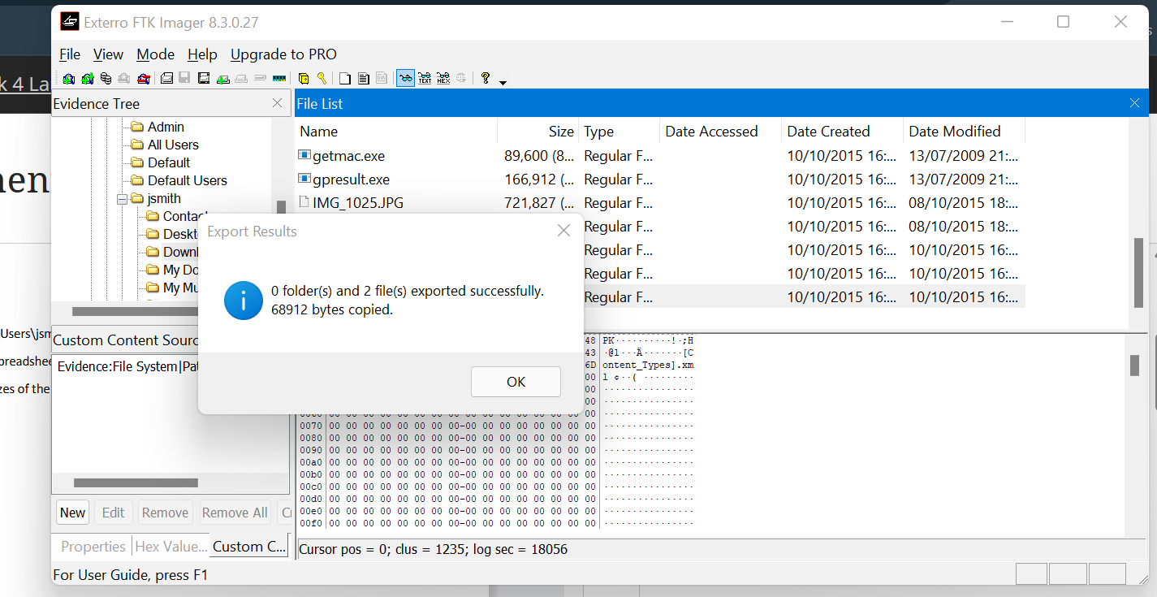

- NAMES AND SIZES OF THE EXCEL SPREADSHEETS.
FILE | SIZE
Forecast.xlsx | 36,888
Projections.xlsx | 32,024

RECOVERING FILES FROM FORENSIC IMAGES FROM AUTOPSY LAB
STEP 5-In the new case information window, I added a case name then a directory to which the case would be stored.
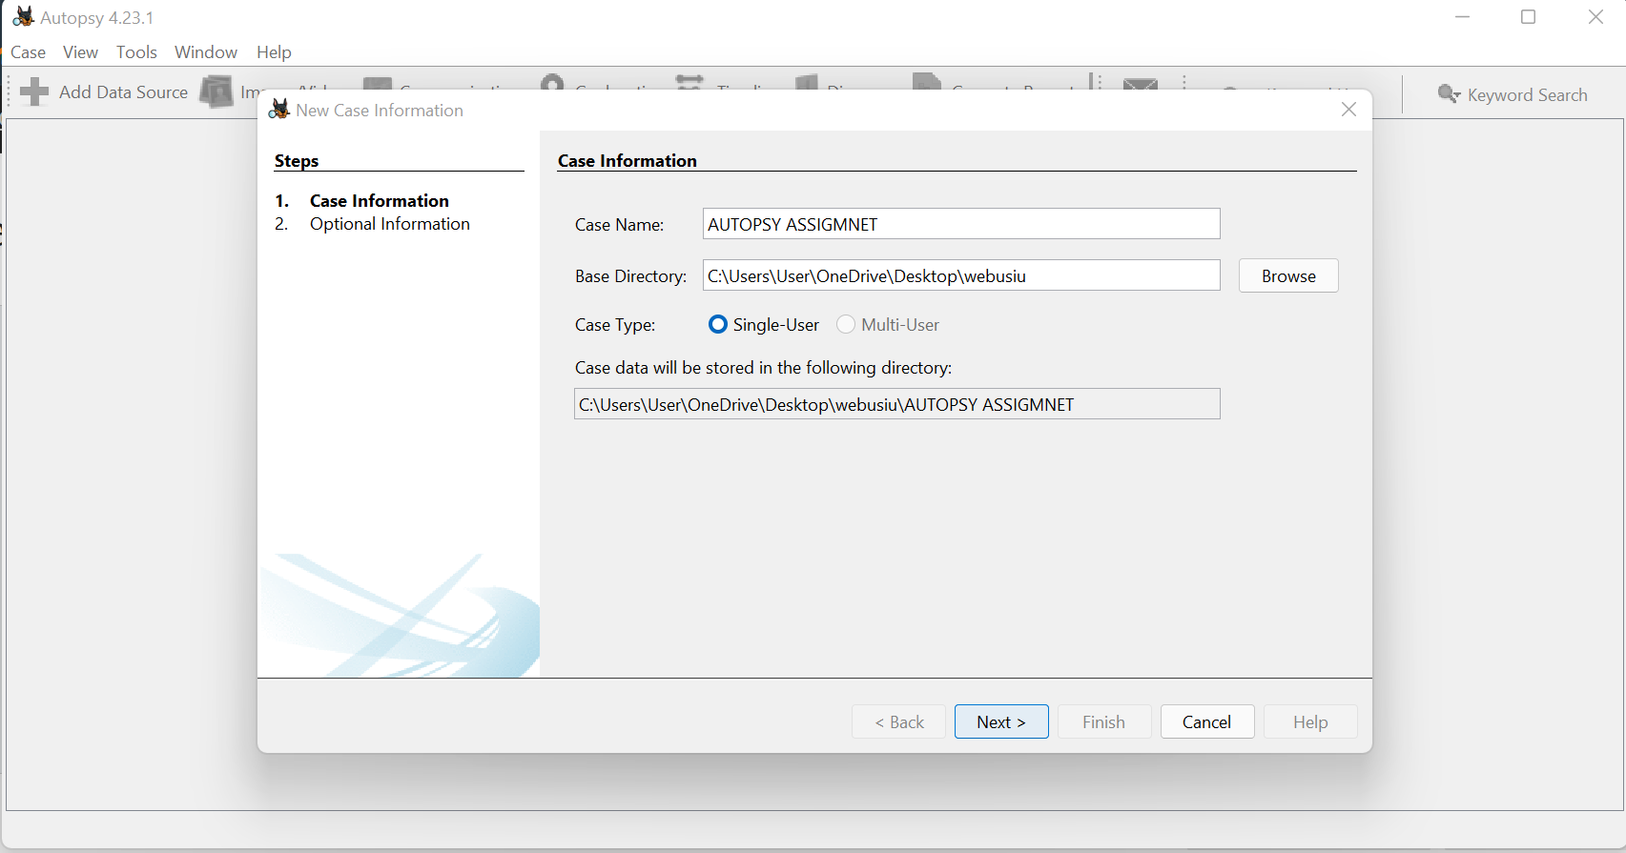

STEP 8-In the Add data source window I browsed to drive 2.E01 and clicked next.
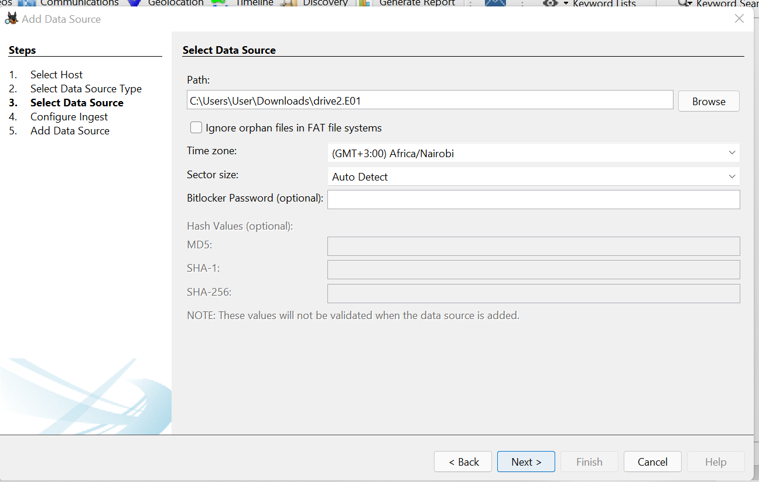

STEP 9-These are the ingest modules I was presented. I am able to see the 3 panels.
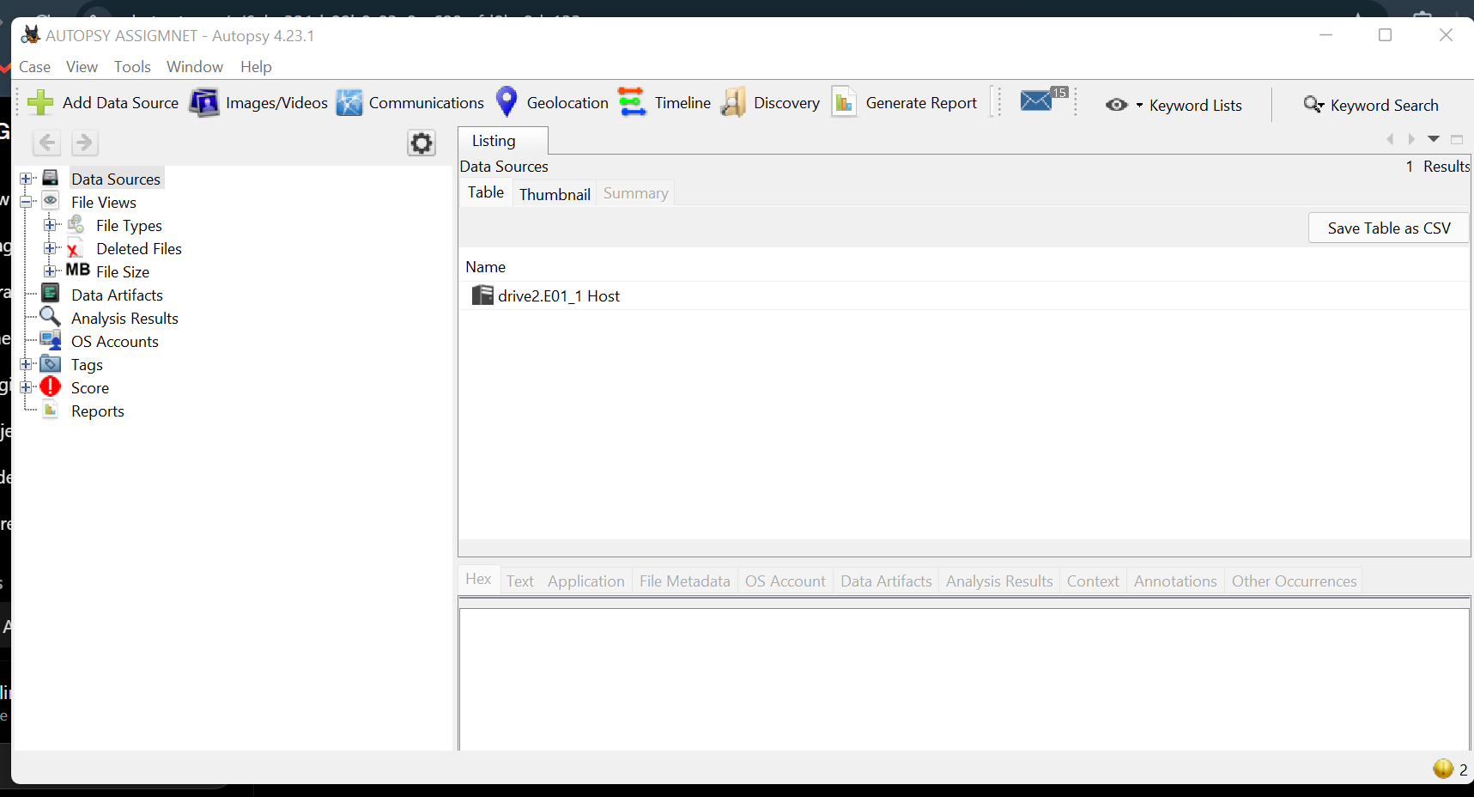

STEP 12 and 13- I click the plus button next to data source and drill down to drive2.E01.I navigate down to C:\windows\system32
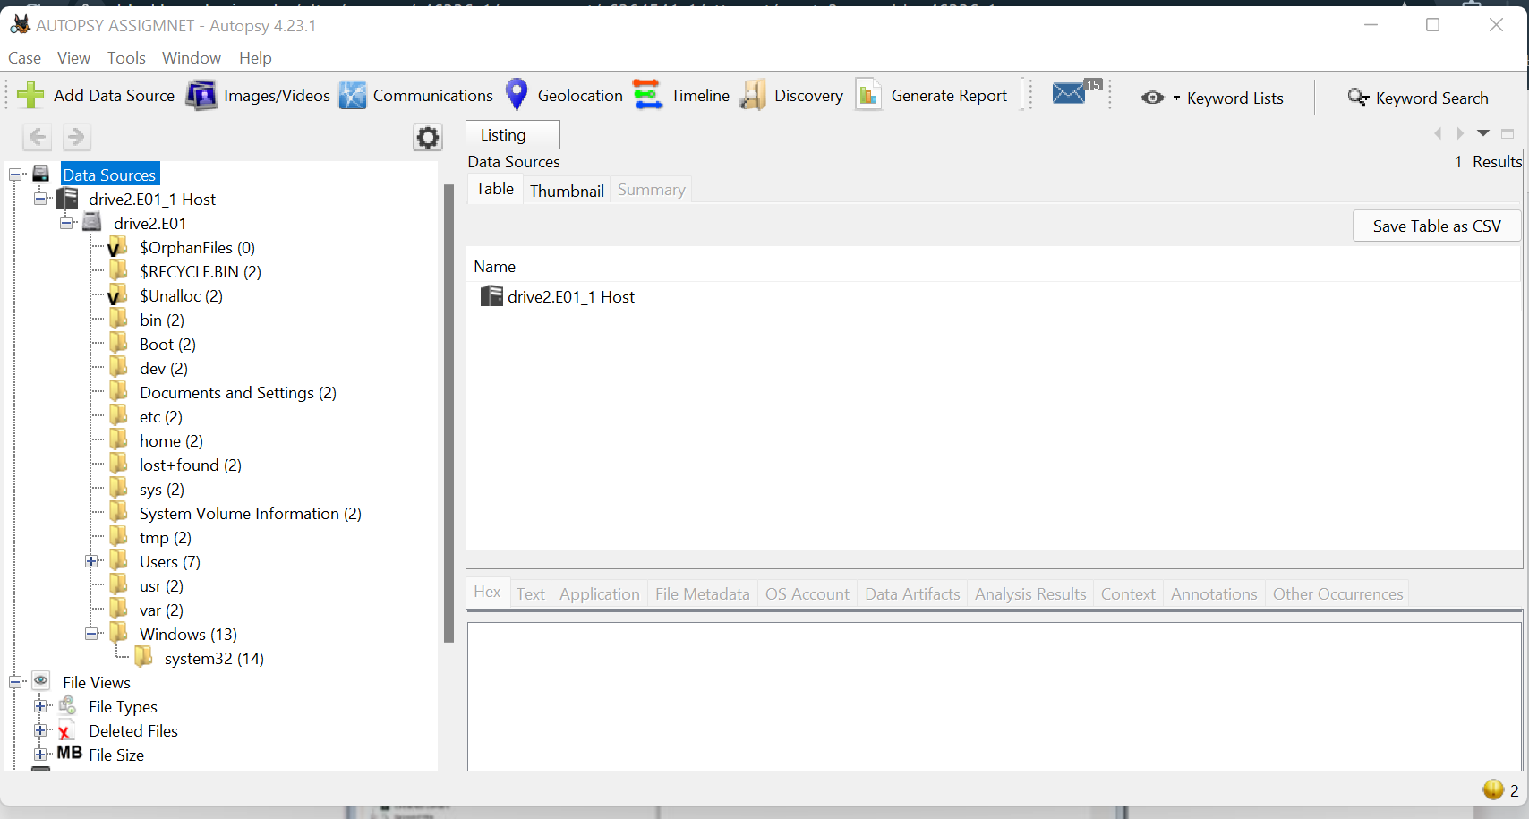

STEP 14-I click on windows 32 and a list of files are presented to me; I look for file named nsadmin.exe then right click to extract the file. I identify a location then click on the save button.
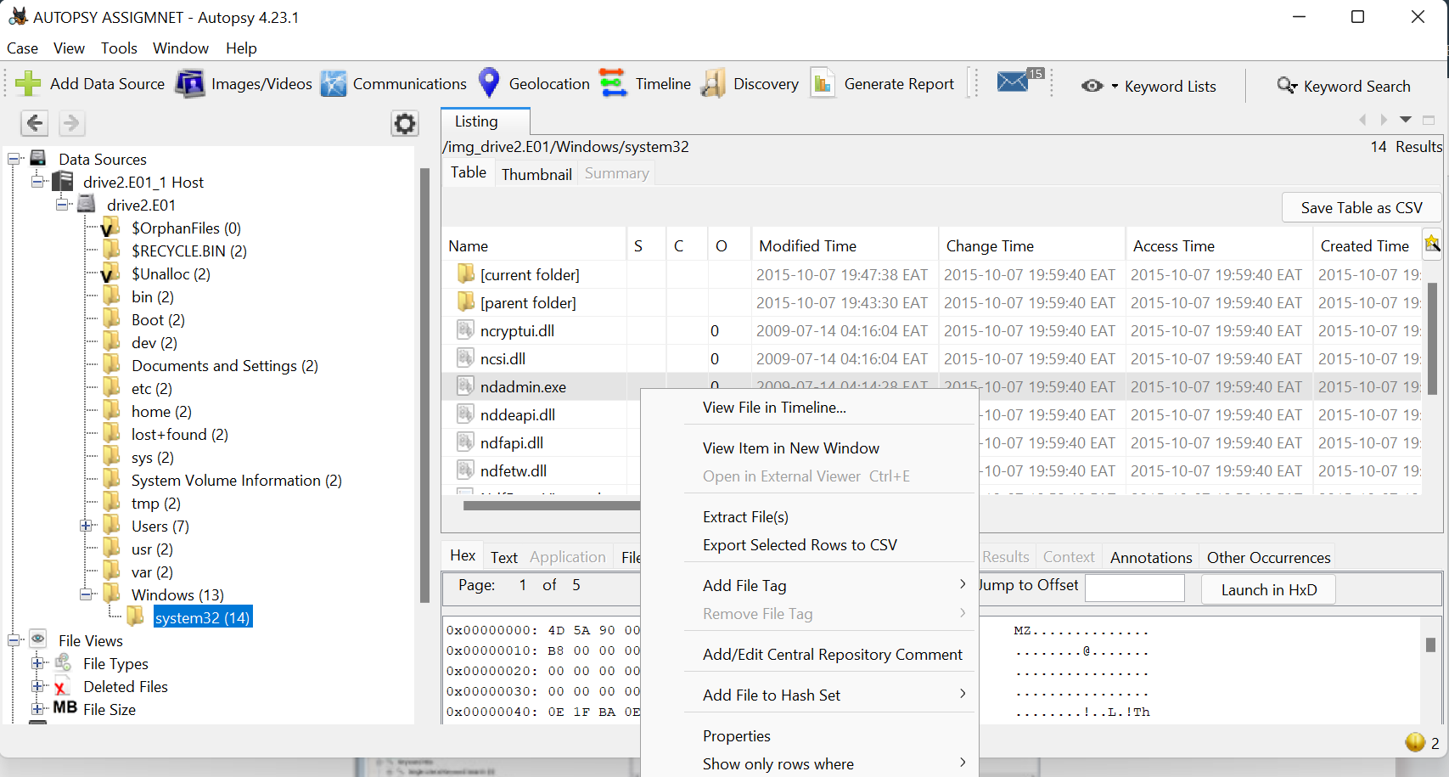

STEP 16- To extract multiple files, I hold the shift key then clicking on the files I want to extract then right clicking and selecting extract files.

